EXERCISE 3 : STORED PROCEDURES

SCENARIO 1: The bank needs to process monthly interest for all savings accounts.
  - Question: Write a stored procedure ProcessMonthlyInterest that calculates and updates the balance of all savings accounts by applying an interest rate of 1% to the current balance.

TABLES USED
CREATE TABLE Accounts (
AccountID NUMBER PRIMARY KEY,
CustomerID NUMBER,
AccountType VARCHAR2(20),
Balance NUMBER,
LastModified DATE
);

INSERTING VALUES INTO THE TABLES
INSERT INTO Accounts (AccountID, CustomerID, AccountType, Balance, LastModified)
VALUES (1, 1, 'Savings', 1000, SYSDATE);

INSERT INTO Accounts (AccountID, CustomerID, AccountType, Balance, LastModified)
VALUES (2, 2, 'Checking', 1500, SYSDATE);

CREATE PROCEDURE
CREATE OR REPLACE PROCEDURE ProcessMonthlyInterest IS
CURSOR savings_cursor IS
SELECT AccountID, Balance FROM Accounts WHERE AccountType = 'Savings';

v_account_id Accounts.AccountID%TYPE;
v_balance Accounts.Balance%TYPE;
v_interest_rate CONSTANT NUMBER := 0.01;
BEGIN
OPEN savings_cursor;
LOOP
FETCH savings_cursor INTO v_account_id, v_balance;
EXIT WHEN savings_cursor%NOTFOUND;

UPDATE Accounts
SET Balance = Balance + (v_balance * v_interest_rate),
LastModified = SYSDATE
WHERE AccountID = v_account_id;
END LOOP;
CLOSE savings_cursor;

COMMIT;
EXCEPTION
WHEN OTHERS THEN
ROLLBACK;
DBMS_OUTPUT.PUT_LINE('Error processing monthly interest: ' || SQLERRM);
END;
/

RUN THE PROCEDURE
BEGIN
ProcessMonthlyInterest;
END;
/

VIEW RESULT
SELECT * FROM Accounts;

OUTPUT
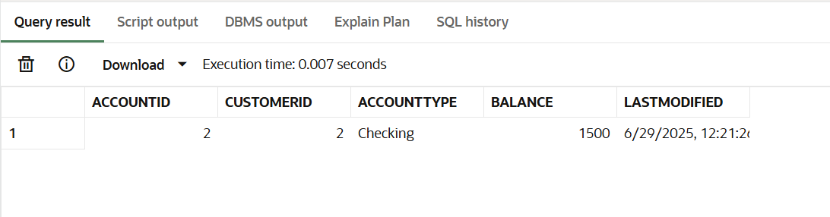

SCENARIO 2: The bank wants to implement a bonus scheme for employees based on their performance.
  - Question: Write a stored procedure UpdateEmployeeBonus that updates the salary of employees in a given department by adding a bonus percentage passed as a parameter.

TABLES USED
CREATE TABLE Employees (
EmployeeID NUMBER PRIMARY KEY,
Name VARCHAR2(100),
Position VARCHAR2(50),
Salary NUMBER,
Department VARCHAR2(50),
HireDate DATE
);

INSERTING VALUES
INSERT INTO Employees VALUES (1, 'Alice Johnson', 'Manager', 70000, 'HR', TO_DATE('2015-06-15', 'YYYY-MM-DD'));
INSERT INTO Employees VALUES (2, 'Bob Brown', 'Developer', 60000, 'IT', TO_DATE('2017-03-20', 'YYYY-MM-DD'));

CREATE PROCEDURE
CREATE OR REPLACE PROCEDURE UpdateEmployeeBonus (
dept_name IN VARCHAR2,
bonus_percent IN NUMBER
) IS
updated_count NUMBER;
BEGIN
UPDATE Employees
SET Salary = Salary + (Salary * bonus_percent / 100)
WHERE Department = dept_name;

updated_count := SQL%ROWCOUNT;

COMMIT;

DBMS_OUTPUT.PUT_LINE(updated_count || ' employee(s) received bonus in department ' || dept_name);
EXCEPTION
WHEN OTHERS THEN
ROLLBACK;
DBMS_OUTPUT.PUT_LINE('Error updating employee bonus: ' || SQLERRM);
END;
/

RUN THE PROCEDURE
BEGIN
UpdateEmployeeBonus('IT', 10);
END;
/

VIEW RESULT
SELECT * FROM Employees;

OUTPUT
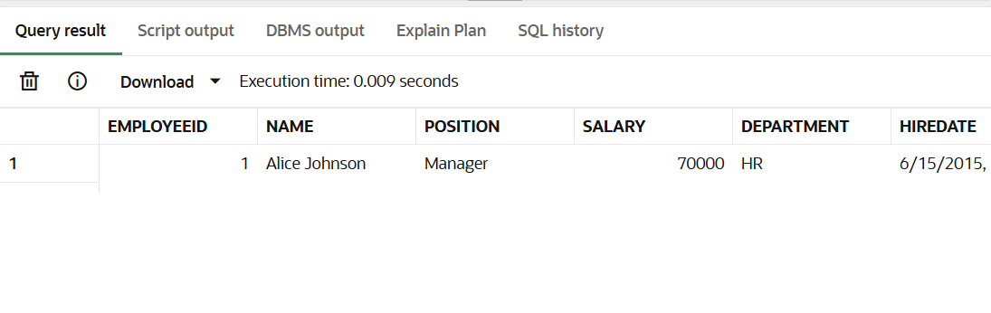
SCENARIO 3 : Customers should be able to transfer funds between their accounts.
  - Question: Write a stored procedure TransferFunds that transfers a specified amount from one account to another, checking that the source account has sufficient balance before making the transfer.

TABLES USED
CREATE TABLE Accounts (
AccountID NUMBER PRIMARY KEY,
CustomerID NUMBER,
AccountType VARCHAR2(20),
Balance NUMBER,
LastModified DATE
);

CREATE TABLE Transactions (
TransactionID NUMBER PRIMARY KEY,
AccountID NUMBER,
TransactionDate DATE,
Amount NUMBER,
TransactionType VARCHAR2(10)
);

INSERTING VALUES
-- Accounts
INSERT INTO Accounts VALUES (1, 1, 'Savings', 1000, SYSDATE);
INSERT INTO Accounts VALUES (2, 2, 'Checking', 1500, SYSDATE);

-- Transactions
INSERT INTO Transactions VALUES (1, 1, SYSDATE, 200, 'Deposit');
INSERT INTO Transactions VALUES (2, 2, SYSDATE, 300, 'Withdrawal');

CREATE PROCEDURE
CREATE OR REPLACE PROCEDURE TransferFunds (
from_account_id IN NUMBER,
to_account_id IN NUMBER,
amount IN NUMBER
) IS
insufficient_balance EXCEPTION;
account_not_found EXCEPTION;

from_balance NUMBER;
to_count NUMBER;
BEGIN
SELECT Balance INTO from_balance
FROM Accounts
WHERE AccountID = from_account_id
FOR UPDATE;

SELECT COUNT(*) INTO to_count
FROM Accounts
WHERE AccountID = to_account_id;

IF to_count = 0 THEN
RAISE account_not_found;
END IF;

IF from_balance < amount THEN
RAISE insufficient_balance;
END IF;

UPDATE Accounts
SET Balance = Balance - amount,
LastModified = SYSDATE
WHERE AccountID = from_account_id;

UPDATE Accounts
SET Balance = Balance + amount,
LastModified = SYSDATE
WHERE AccountID = to_account_id;

INSERT INTO Transactions
VALUES (Transactions_seq.NEXTVAL, from_account_id, SYSDATE, amount, 'Debit');

INSERT INTO Transactions
VALUES (Transactions_seq.NEXTVAL, to_account_id, SYSDATE, amount, 'Credit');

COMMIT;
EXCEPTION
WHEN insufficient_balance THEN
ROLLBACK;
DBMS_OUTPUT.PUT_LINE('Transfer failed: insufficient funds.');
WHEN account_not_found THEN
ROLLBACK;
DBMS_OUTPUT.PUT_LINE('Transfer failed: destination account not found.');
WHEN OTHERS THEN
ROLLBACK;
DBMS_OUTPUT.PUT_LINE('Transfer failed due to an unexpected error: ' || SQLERRM);
END;
/
RUN THE PROCEDURE
BEGIN
TransferFunds(1, 2, 300); -- Transfer $300 from account 1 to 2
END;
/

VIEW RESULT
SELECT * FROM Accounts;
SELECT * FROM Transactions;

OUTPUT
